## 

## 

## 

**Week 1**

**Photoshop in Design**

**5th December 2023**

# Overview

Getting into design might seem overwhelming with all the tools available, but a good starting point is learning Photoshop. It's widely used for creating and editing images. In today's world, design skills are super important, not just for artists but also in business and marketing. Knowing your way around Photoshop opens up creative possibilities, helping you communicate effectively in our image-focused society. So, let's start exploring and make design work for you!

# Goals

1. To learn all the basic tools and also some advanced concepts such as

* **Adding Shapes.**
* **Adding Curved Texts.**
* **Adding style and filter to your texts.**
* **Adding gradient backgrounds.**
* **Making repeating patterns.**
* **Make your brushes.**
* **Masking.**
* **Using the magnetic lasso tool.**

1. To make a hands-on project that can be added to your ever-growing design portfolio.

# Getting Started

## Software Setup and Beginner Tips

* First, you will need to get Photoshop installed on your systems. The following link will provide you with the download link of the software: [Adobe Suite](https://drive.google.com/drive/folders/1pjPehttM-Oz_D0KSdj4ZOzJ8VZRpi7Nt)
* Adobe Suite for Mac users: [Mac](https://drive.google.com/drive/folders/1Zcb8POxSgz49sXiTc17sXT7AZf_DQP2K?usp=sharing)
* Next will be setting up the software for your system and then applying some **changes to the layout** so that it will be helpful for you to access some of the properties and cool styles on the go. You can see the slides provided here; [Setup Guide for Photoshop](https://docs.google.com/presentation/u/0/d/1aCOeW1CmBzsMgishf7t-Ezl9yLYhdNP4ObWBYATf_cc/edit)  afterward for doing the same.
* Also, this software makes a ton of **temporary files** while they run and they can quickly fill up your storage so the best way to avoid that is to change your **scratch disks**.
* A **scratch disk** is just the storage drive you use to store the temporary files, once the program is closed all the temporary files are removed automatically. You can see how to change a scratch disk in the previous slide given.

Exporting your Image

* In the end, when you are done with making your designs you need to **export** them in some **specific formats** that will be requested by your employer.
* Most often in graphics the format used is an image format. These formats are namely, **.png**, **.jpeg**, **.svg,** or some other image formats.
* In the following slides, you can learn how to export your designs: [Exporting in Photoshop](https://docs.google.com/presentation/d/1teVulIpXxA4ppBnOdRpgROgtdz9o6CSLbs8ry7zK8zI/edit?usp=sharing).
* Learning to effectively export will help you a lot when your files don't go missing and are in the proper format.

# Lessons

## Making shapes and Curves and Adding Basic Styles to Texts

**Shapes and curves** are the most used assets in the field of design. They help to define boundaries and add a bit of a natural twist to your design when you need one. Adding shapes to your designs is like adding salt to a dish you always have to use it.

Now we will be starting our artistic journey by making some common shapes and then moving on to curves we will start adding curved texts and some style elements to the text.

These small steps are very building blocks of amazing design and graphics you see in your day-to-day life

* First, you will create a blank canvas that will have a background color of black.
* Then we will add some shapes to it by using the shape tool and fill them with varied colors, arranging them in such a manner as shown in the reference image.
* Then we will add a curved neon text at the bottom to add a bit of a glowing effect to the whole art. [Neon Text Effect](https://www.youtube.com/watch?v=OoX9scQ57lc)
* At the end, you will be submitting an image with these shapes put into any way you like, you can see the reference image to get some ideas

See the image for reference :

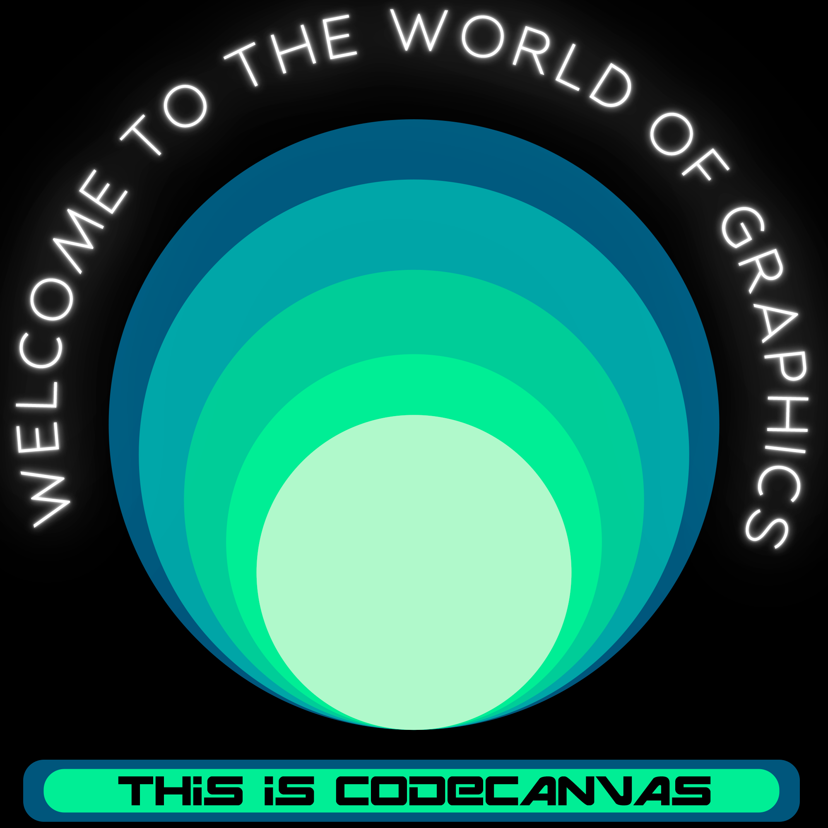

## Adding Gradient Backgrounds and Making Patterns

**Gradients** are another part of the design, used to show **transitions** between colors or can be used by experts to make some amazing masks and edits. **Patterns** are just **repetitions** of the same shape or object that make a visually appealing element in the Scene.

Adding these will certainly add a great sense of **neatness and experience** to your designs. What we will be implementing are :

* We will be making a dot pattern and a strip pattern which are some of the most basic types of patterns in the field of design, these are also called an array of elements.
* First, you will be making a circle and then just copying it to make an array and that's how you do it to make some patterns. The same goes for the strips.
* For the LIne patterns using a brush is a great technique to make some amazing backgrounds to your image. you can learn to make the line pattern through the following link : [How to create abstract lines in Photoshop 🧬](https://www.youtube.com/watch?v=MZeK6qqylhU)
* In the end, you will be making a canvas that will have these patterns to form a sort of background of an image that we will be further putting into it.
* At the end, you will be submitting an image with these assets put into any way you like, you can see the reference image to get some ideas

See the image for reference:

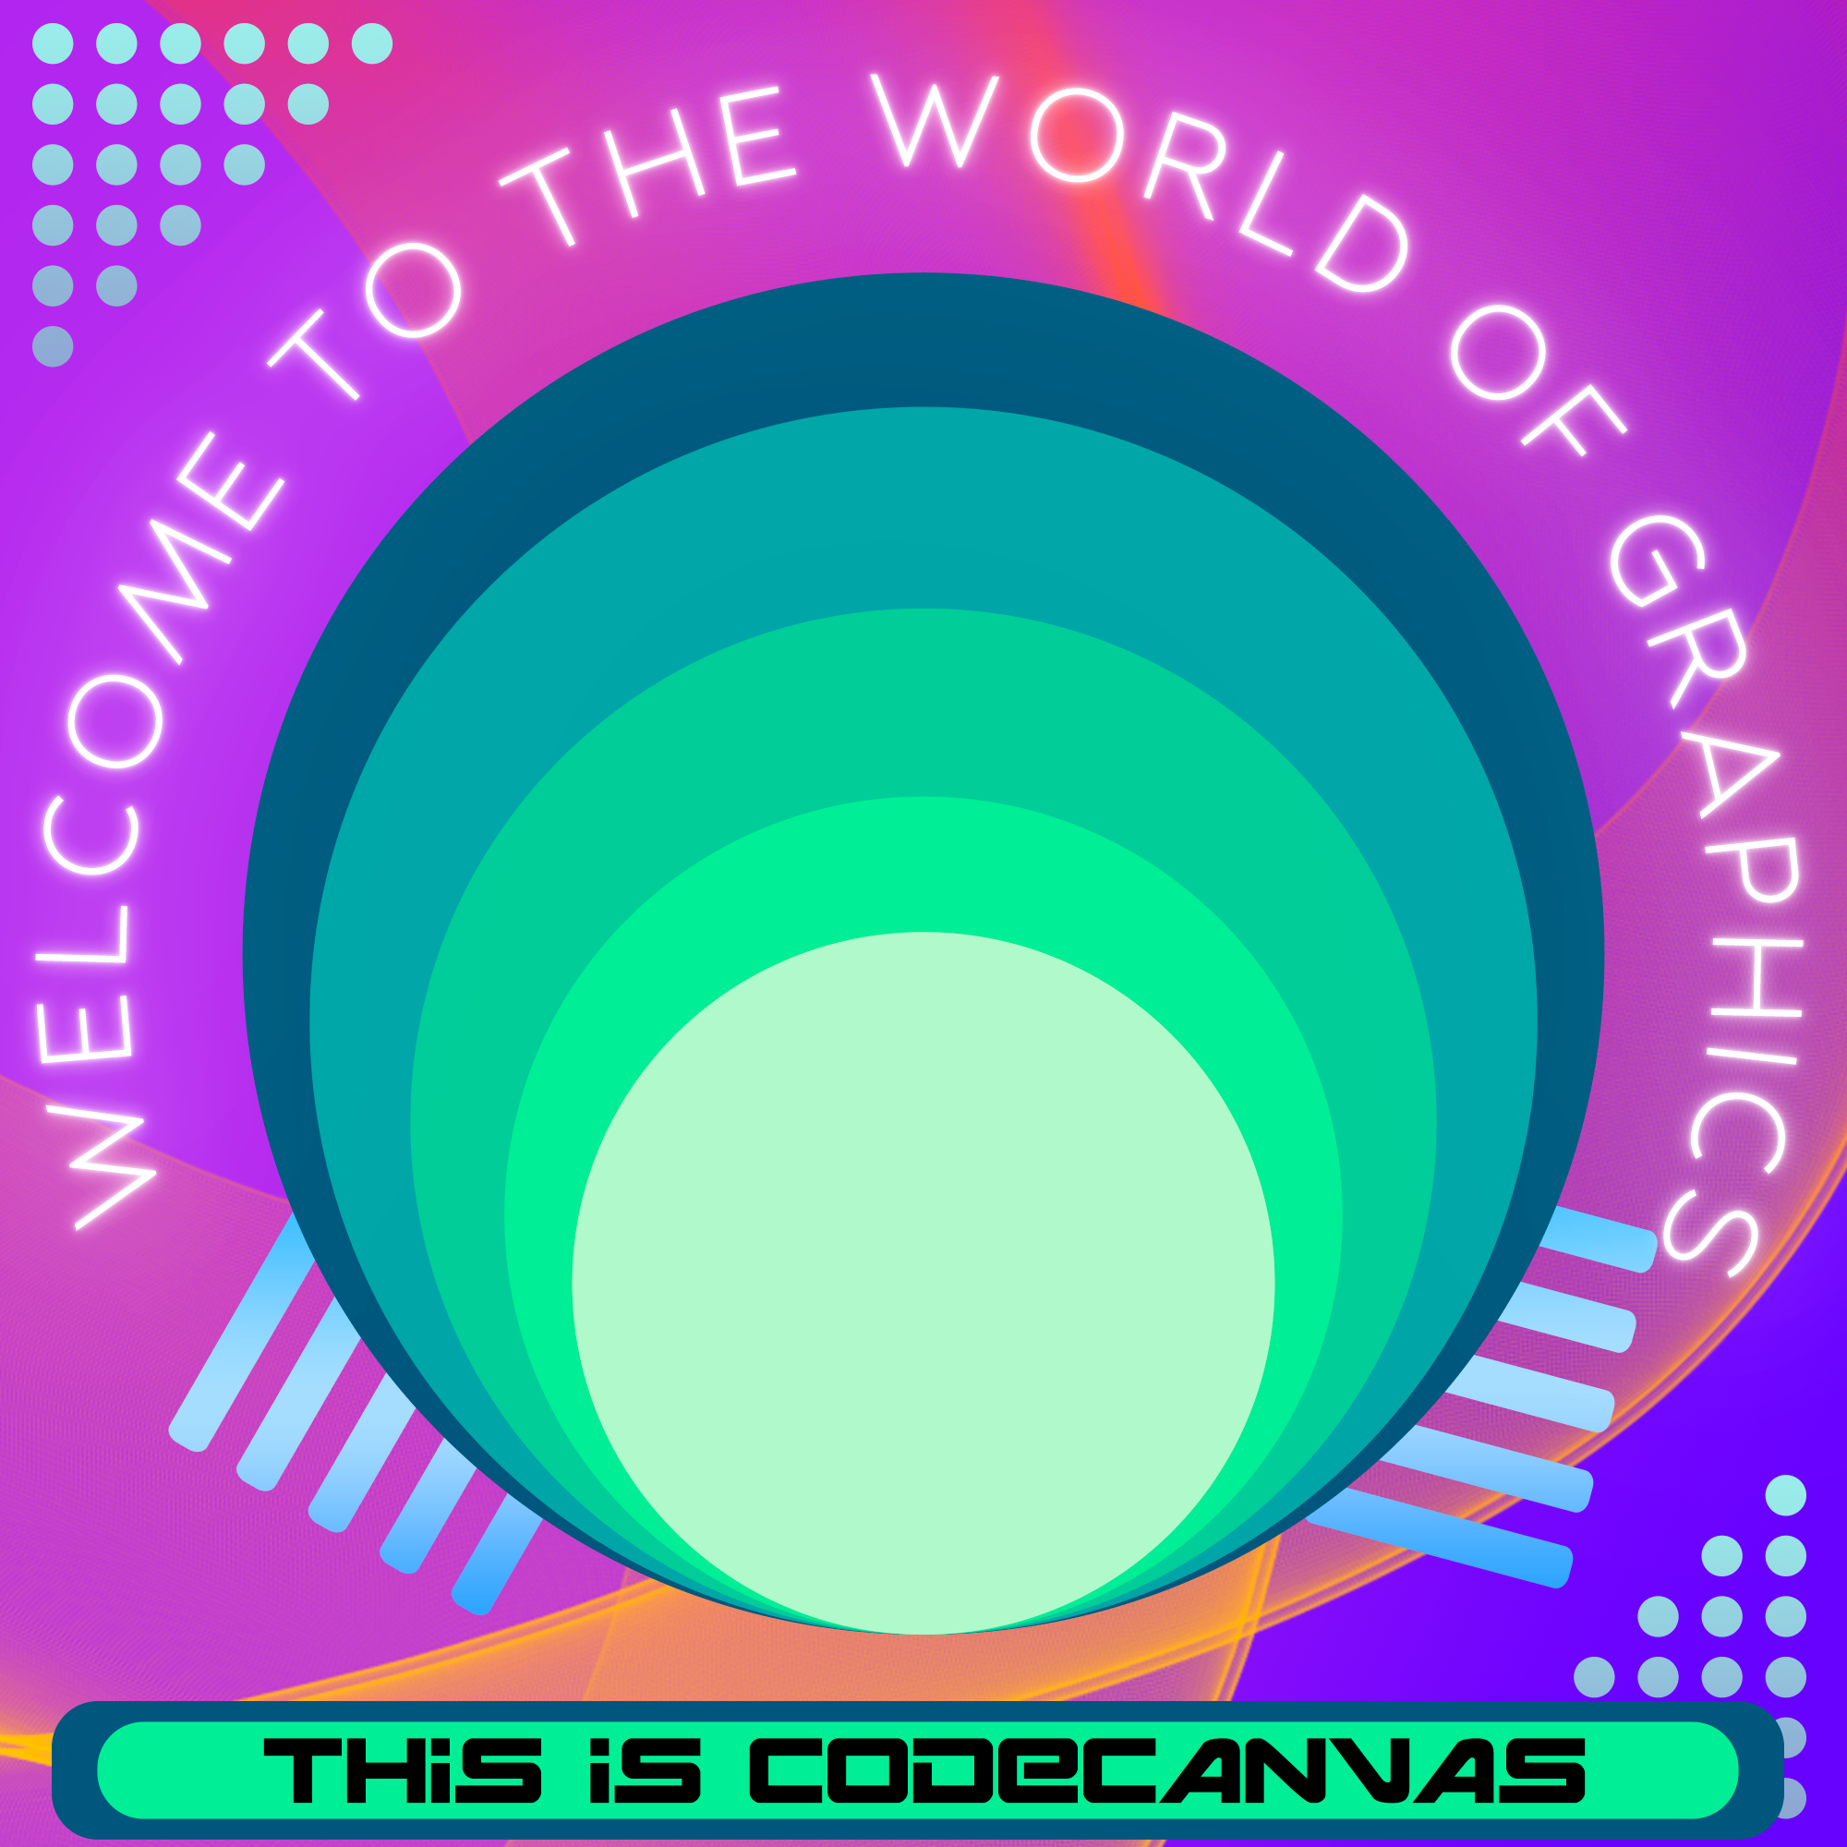

1. Masking Images and Magnetic Lasso.

**Masking** is the technique used to make images or any other layers used in the field of graphics fit **inside specific shapes or object** and are very helpful when you need to add images to some odd shapes. Magnetic lasso on the other hand is an amazing selection tool that helps you select the subject of any image and then make a cut out of it

In this next lesson, you will be using one of your image to cut yourself out from the image and paste it on a new background of your choice.

Masking can be learned from the following link: [Clipping Mask - Adobe Photoshop for Beginners - Class 18 - Urdu / Hindi](https://www.youtube.com/watch?v=gW7SQl-CIu8&t=110s)

1. The Final Showdown

For the final piece of the puzzle, we are going to combine all these elements to make a beautiful self-portrait of you where you choose an image of yours and apply all the techniques you have learned.

See the image for reference:

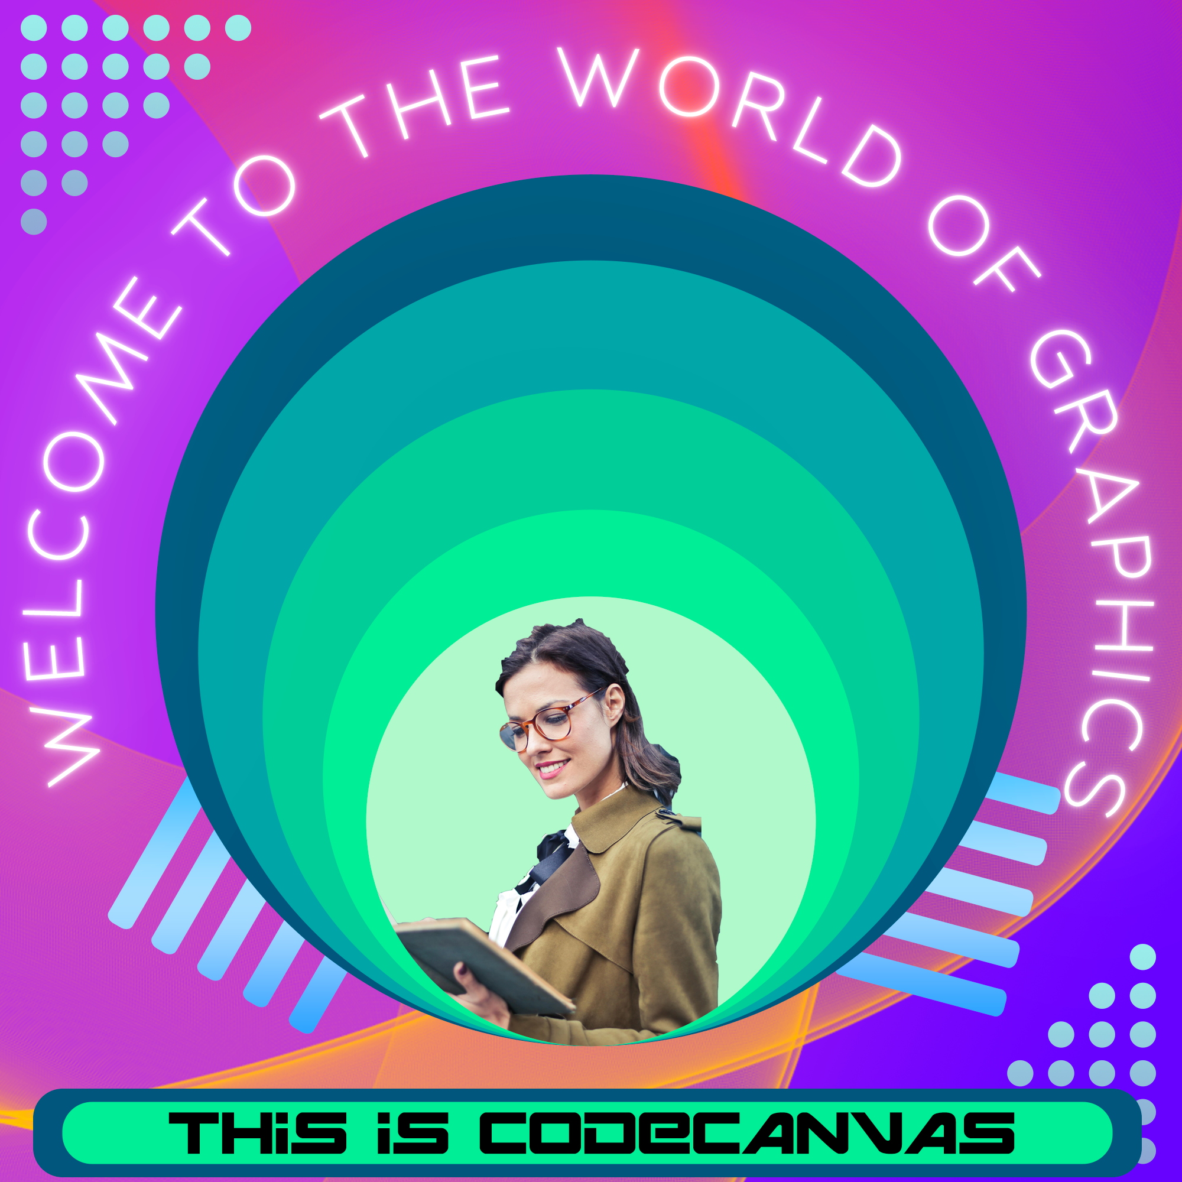

# Resources

These are the resources that you will need to learn some of the basics of the software and we have also added a few of our special links where we go for inspiration and also to learn.

Tutorials to learn the basics of Photoshop: [Basic Selections - Adobe Photoshop for Beginners - Class 1 [Eng Sub]](https://www.youtube.com/watch?v=ZByhs9mDtDg&list=PLW-zSkCnZ-gA5Jn6gZtUa6-aG0OoRZyb6)

Videos to watch in this playlist are 1-5, 7-12, 14-18, 20-22, and 24.

Making the line brush used in Lesson 2: [How to create abstract lines in Photoshop 🧬](https://www.youtube.com/watch?v=MZeK6qqylhU)

Masking in Photoshop: [Clipping Mask - Adobe Photoshop for Beginners - Class 18 - Urdu / Hindi](https://www.youtube.com/watch?v=gW7SQl-CIu8&t=110s)

Some Cool Text effects To try out: <https://fixthephoto.com/best-photoshop-text-effects-tutorials.html>

Getting stuck with choosing colors or a range of colors, you can try this amazing website that professionals use to get color palettes: [Coolors - The super fast color palettes generator!](https://coolors.co/)

# Submission

You will have to export **.png** of each of the Lessons that you complete and also separate **.psd** files in a Google Drive folder with proper access given for the grading of your responses.

A Google form will be shared with you through email where you will be submitting your creations.

**Hope you enjoyed your creative journey through Photoshop. Be ready for the upcoming learning ahead.**